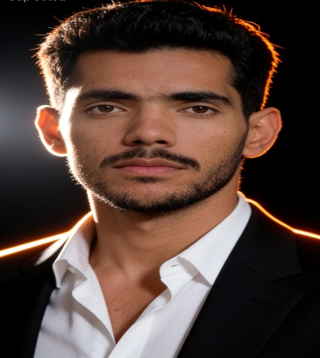
[ INTERMEDIATE ]
[2022 – 2024]
[ STAR SCIEENCE ACADEMY FAZILPUR,DISTRICT RAJANPUR.]

[ BACHELOR’s OF COMPUTER SCIENCE ]
[2024 – 2028]
[ KHWAJA FAREED UNIVERSITY OF ENGINEERING AND INFORMATION TECHNOLOGY SUB-CAMPUS RAJANPUR. ]
GHAYOOR ABBAS
WEB-DEVELOPER
Creative and detail-oriented Web Developer and Designer with a strong foundation in front-end and back-end development, coupled with a keen eye for user-centric design. Proficient in technologies like HTML, CSS, JavaScript, and frameworks such as React and Bootstrap, with experience in creating responsive, visually appealing websites and applications. Adept at collaborating with cross-functional teams to deliver seamless user experiences.

+923327571531
+923319678382

NILL

ghayoormastoi1531@gmail.com
[ Innovative Web Development ] [Web Developer & Designer]
JAN 2025 – PRESENT

- Designed and developed responsive websites using HTML and CSS, enhancing user engagement.

[ C++ PROGRAMMING ]
SEPTEMBER 2024 – PRESENT

- Designed and developed responsive websites using HTML and CSS, enhancing user engagement.

